Practical No. 5
Aim : WAP to display array elements using for-each loop

Name : Danish Altaf Solkar | Class : CO - B
Enrolment no. : 24111590805 | Batch : 2

Code :-
public class Forloop
{
public static void main(String [] args)
{
int [] numbers = {10,20,30,40,50};
System.out.println("Array elements are : ");
for(int number : numbers)
{
System.out.println(number);
}
}
}

OUTPUT :-
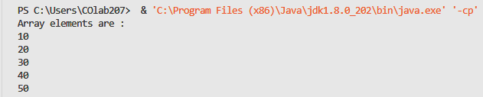

Process related  (35) | Product related  (15) | Total Marks  (50) | Signature

Practical No. 5
Aim : WAP to insert different elements in Vector and display them

Name : Danish Altaf Solkar | Class : CO - B
Enrolment no. : 24111590805 | Batch : 2

Code :-
import java.util.*;
class VectorDemo
{
public static void main(String [] args)
{
Vector v1 = new Vector(7);
v1.addElement(10);
v1.add(30);
v1.add(50);
v1.add(20);
v1.add(40);
v1.add(10);
v1.add(20);
System.out.println("The elements in the vector are : "+v1);
}
}

OUTPUT :-

Process related  (35) | Product related  (15) | Total Marks  (50) | Signature

Practical No. 5
Aim : WAP to use Different methods of Vector class
Name : Danish Altaf Solkar | Class : CO - B
Enrolment no. : 24111590805 | Batch : 2
Code :-
import java.util.Vector;
class VectorDemo
{
public static void main(String [] args)
{
Vector<Integer>v1 = new Vector<>();
//Adding elements
v1.add(10);
v1.add(30);
v1.add(50);
v1.add(20);
v1.add(40);
v1.add(10);
v1.add(20);
System.out.println("The elements in the Vector are : "+v1);
System.out.println("The original size of Vector : "+v1.size());
//Removing elements
System.out.println("Removing the Third element");
v1.remove(2); //Removes 3rd element
System.out.println("Removing the Fourth element");
v1.remove(3);
System.out.println("Now the elements in the Vector are : "+v1);
//Inserting element
System.out.println("Inserting element 100 at 3rd position : ");
v1.insertElementAt(100,2); //Insert at index 2
System.out.println("Now the elements in the Vector are : "+v1);
System.out.println("The current size of Vector : "+v1.size());
}
}

OUTPUT :-
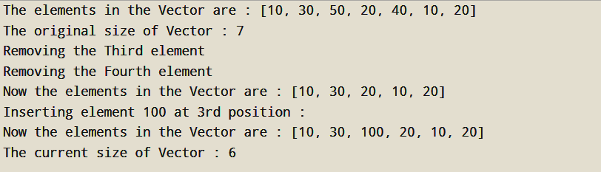

Process related  (35) | Product related  (15) | Total Marks  (50) | Signature

